Pennsylvania Southeast Conference
of the United Church of Christ

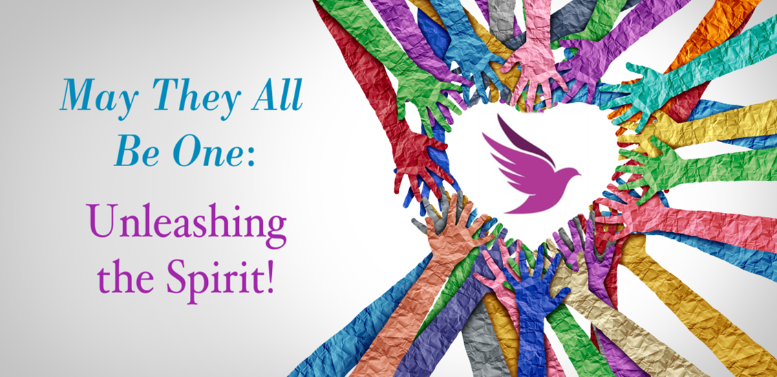

Closing Worship
Saturday, June 3, 2023
2023 Annual Meeting

OPENING HYMN O God in Whom All Life Begins NCH 401

O God in whom all life begins, who births the seed to fruit,
bestow your blessing on our lives; Here let your love find root.
Bring forth in us the Spirit’s gifts of patience, joy, and peace;
deliver us from numbing fear, and grant our faith increase.

Through tears and laughter, grief and joy, enlarge our trust and care;
so bind us in community that we may risk and dare.
Be with us when we gather here to worship, sing, and pray,
then send us forth in power and faith to live the words we say.

CALL TO COMMUNITY
Leader: We were created in relationship and for relationship.
All: We are created for community!

Leader: God knew it was not right for us to be alone.
All: We are created for community!

Leader: Through Jesus Christ, God entered into human relationship
with us.
All: We are created for community!

Leader: We rejoice in our unity with all humanity.
All: We are created for community!

INVOKING
Holy God, as distant as the farthest star and as close as our next breath, we gather to witness to Your presence in our lives. Hear the confessions of our mouths, the yearnings of our hearts and the hope in our dreams. May Jesus’ promise, “Where two or three are gathered in my name, there I am…,” be fulfilled. Make us a joyful community so that with the faithful in every time and place we may praise and honor the You that is in US, O God our Rock and our Redeemer. Amen.

CONFESSION
Leader: God-made-flesh,
Bone of our bone,
We confess that we think we can go it alone,
That we try to do it all,
That in doing so, we neglect the gifts you have given us:
The bone of our bone,
The flesh of our flesh,
The bodies you created,
And the relationships you created us for.

All: Jesus Christ, you who lived in a human body,
Call us to community.
Remind us that in you we are one.
Awake in us a respect for one another,
And celebrate with us the diversity within that unity.
May it be so now and forever. Amen.

ASSURANCE
Leader: You are the divine creation, and it is not right for you to be
alone.
Know now that you are forgiven and called back into relationship
with God and with one another.

Soloist Ms. Cheryl Rathbun “Let There Be Peace on Earth”

READINGS
Leader: Genesis 2: 18-22 (The Message)
God said, “It’s not good for the Man to be alone; I’ll make him a helper, a companion.” So, God formed from the dirt of the ground all the animals of the field and all the birds of the air. He brought them to the Man to see what he would name them. Whatever the Man called each living creature, that was its name. The Man named the cattle, named the birds of the air, named the wild animals; but he didn’t find a suitable companion.

God put the Man into a deep sleep. As he slept, he removed one of his ribs and replaced it with flesh. God then used the rib that he had taken from the Man to make Woman and presented her to the Man.

John 17:17-23 (NRSV)
Leader: Sanctify them in the truth; your word is truth. As you have sent me into the world, so I have sent them into the world. And for their sakes I sanctify myself, so that they also may be sanctified in truth.

“I ask not only on behalf of these but also on behalf of those who believe in me through their word, that they may all be one. As you, Father, are in me and I am in you, may they also be in us,[f] so that the world may believe that you have sent me. The glory that you have given me I have given them, so that they may be one, as we are one, I in them and you in me, that they may become completely one, so that the world may know that you have sent me and have loved them even as you have loved me.

HOMILY
HYMN Help Us Accept Each Other NCH 388
Let your acceptance change us, so that we may be moved,
In living situations to do the truth and love;
to practice your acceptance, until we know by heart,
the table of forgiveness and laughter’s healing art.

God, for today's encounters with all who are in need,
who hunger for acceptance, for righteousness and bread,
Bring us new eyes for seeing, new hands for holding on;
renew us with your spirit; God! Free us, make us one!

COMMUNION
Leader: First, God created one person.
All: But it was not right for that one person to be alone.

Leader: That person had God, but needed an equal, another.
All: so, God made animals.

Leader: But it still wasn’t enough, so God made another person, an equal, someone to share with, and talk with.
All: God created relationship. God created communion.

Leader: This at last is bone of my bone, flesh of my flesh! And then God went one step further.
All: God looked at the many people living in relationship with one another and decided to join the community!

ALL CM’s: God came to be with us as one of us, and his human family called him Jesus.
All: This at last is bone of my bone, flesh of my flesh!

Leader: And one night, when Jesus sat with his community, he took bread, and broke it, and blessed it, saying, “This is my body.”

Leader: Then he took the cup, saying, “This is my blood.”

Leader: This at last is bone of my bone, flesh of my flesh!

Leader: Come, Holy Spirit, and make us one body of Christ.

All: This at last is bone of my bone, flesh of my flesh!
Leader: Bone of our bone; flesh of our flesh: one with each
other and all humanity: the Body of Christ.

We invite you to share in the bread and the cup together, passing it to the person next to you, and saying to one another, “Bone of our bone; Flesh of our flesh: The Body of Christ!”

BLESSING
The grace of God, deeper than our imagination; the strength of Christ, stronger than our need; and the communion of the Holy Spirit, richer than our togetherness; guide and sustain us today and in all our tomorrow's. Amen.

CLOSING HYMN Thank our God for Sisters, Brothers NCH 397
Thank our God for sisters, brothers, one by grace, in harmony,
joining heart to heart with others, making strong community.
With the cross of Christ our standard, let us sing as with one voice,
Glory, glory, yours the promise: we who are the church rejoice!

Holy is your name forever! Heal divisions that remain;
Bless the church’s new endeavors; make our witness one again.
One in Christ and in Christ's gospel, make us one we now implore.
Glory, glory, yours the glory, then and now and ever more.

Songs covered by One License # 708988

- We thank Ms. Caroline Dunleavy and Ms. Cheryl Rathbun for sharing their musical talents with us this afternoon.
- We thank the Conference Ministers from the Penn Central Conference, Penn Northeast Conference and Penn West Conference for joining us today.

https://www.ucc.org/worship-way/pentecost-19-world-communion-october-3/

