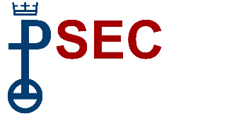
PSEC Fall Meeting
November 13, 2022

Agenda

Opening Worship
w/ Introduction to Salt and Light UCC/PCUSA Merger and Ministry
Presentation by Bethany Children’s Home CEO, Dr. Joseph Birli
Presentation by PSEC Ministry Teams
Addiction & Recovery
Climate Justice Working Group
Disaster Ministries
Racial Justice Initiative
Elections
Break
Finance Presentation
Finance Report
Stewardship Campaign
Spending Plan for 2023
Additional Business
Closing & Benediction

